 | ЗАКОН  О ПОТВРЂИВАЊУ ИЗМЕНЕ И ДОПУНЕ БР. 2 УГОВОРА О ЗАЈМУ ПОТПИСАНОГ ИЗМЕЂУ ФОНДА ЗА РАЗВОЈ АБУ ДАБИЈА И ВЛАДЕ РЕПУБЛИКЕ СРБИЈЕ ЗА ФИНАНСИРАЊЕ ПОДРШКЕ БУЏЕТУ РЕПУБЛИКЕ СРБИЈЕ  ("Сл. гласник РС - Међународни уговори", бр. 5/2026)
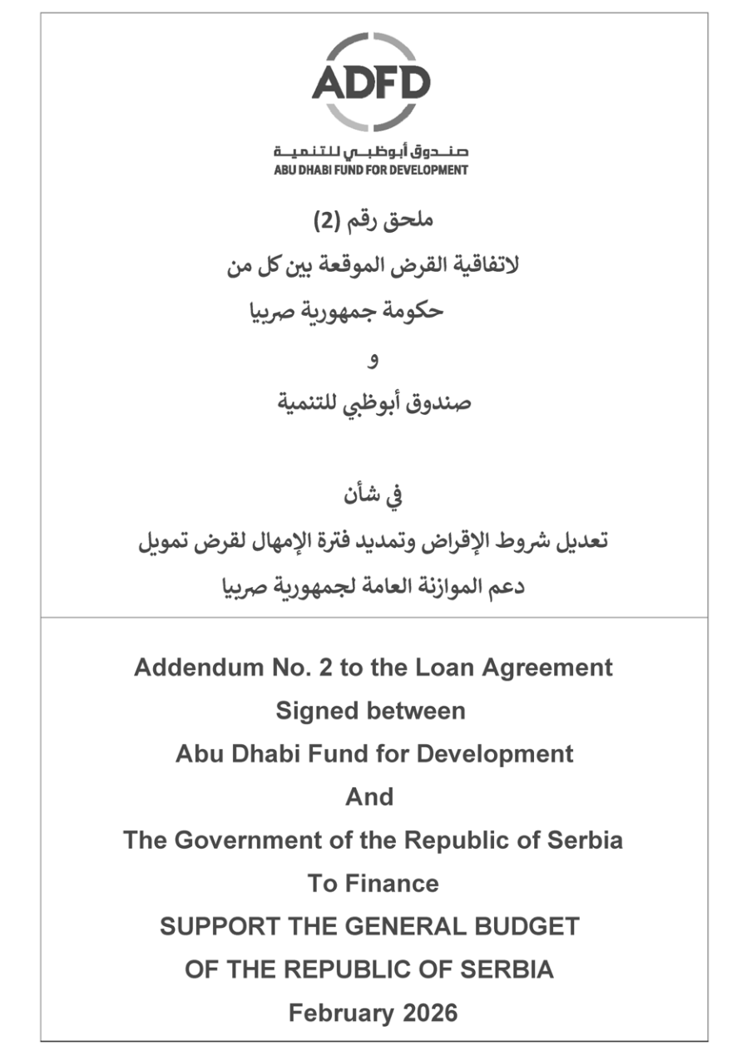
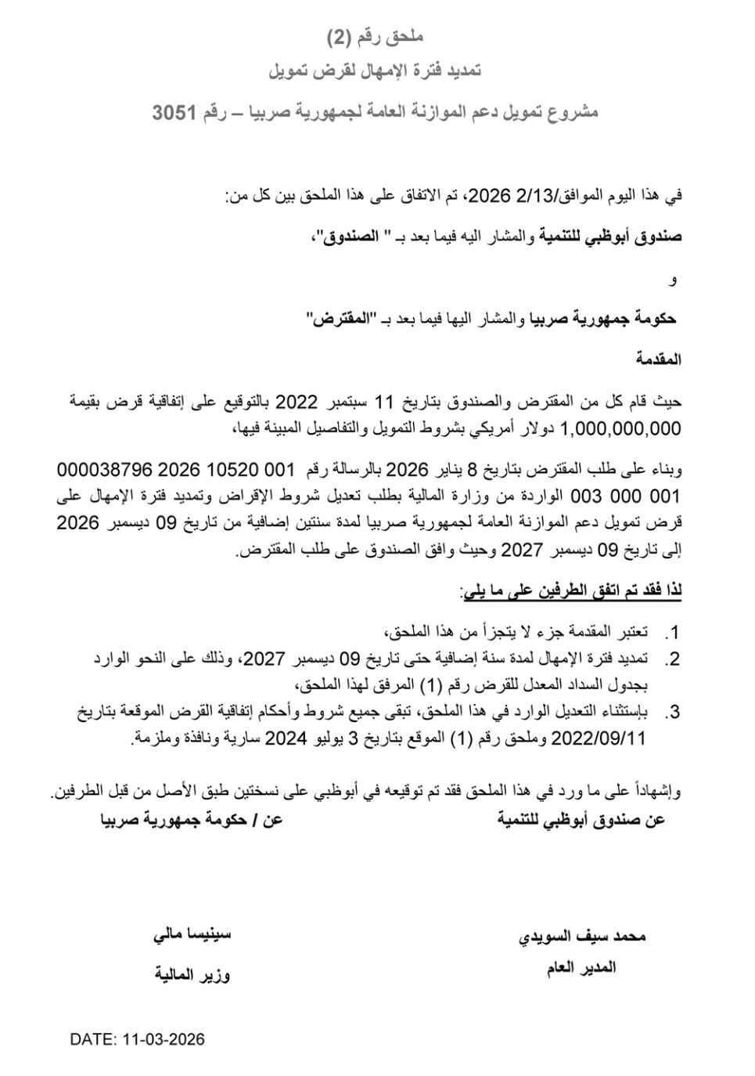
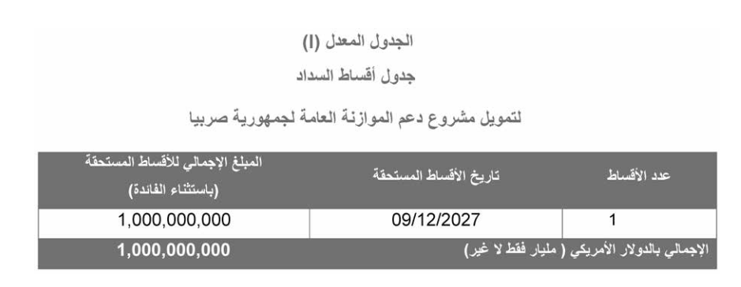
ADDENDUM NO (2)
EXTENSION OF THE DATE OF DUE INSTALLMENTS OF THE LOAN TO SUPPORT THE GENERAL BUDGET OF THE REPUBLIC OF SERBIA - LOAN 3051
On this day the Friday,13/02/2026, this Addendum has been entered By & Between:
Abu Dhabi Fund for Development, hereinafter shall be referred to as the "Fund", and
The Government of the Republic of Serbia, hereinafter shall be referred to as the "Borrower", and
Preamble
Whereas, the Borrower and the Fund entered on the 11th of September 2022 into a Loan Agreement in the amount of USD. 1,000,000,000 as per the conditions listed in it,
Whereas, the Borrower has requested in their letter No. 000038796 2026 10520 001 003 000 001 from The Ministry of Finance dated 08 January 2026 to extend the Date of due Installments of the Loan to Support the General Budget of the Republic of Serbia from 9 December 2026 to 9 December 2027,
Whereas, the Fund has agreed on the borrower request,
Therefore, both parties agree to the following:
1. The preamble shall be considered an integral part of this Addendum.
2. Extension of the Date of due Installments of the loan to Support the General Budget of Republic of Serbia to 09 December 2027, as stated in the amended repayment schedule for Loan No. (1) attached to this Addendum.
3. All other terms, conditions and schedules in the said Loan Agreement of the 11th of September 2022 and addendum no. 1 of the 3rd of July 2024 shall remain applicable and in force.
In Witness Whereof, this Addendum has been signed in 2 original copies at counterparts.
For/ The Government ofthe Republic of Serbia  Siniša Mali  Minister of Finance |  | For/ Abu Dhabi Fund for Development  Mohammed Saif Al Suwaidi  Director General
DATE: 11.03.2026.
Addendum Schedule (I)
Schedule of Amortization
Support The General Budget of the Republic of Serbia
No. of Installment | Date of due Installments | Total Amount of due Installments  (excluding interest)
1 | 09/12/2027 | 1,000,000,000
Total in USD (One Billion US$) |  | 1,000,000,000

